**Backend Interface Specification**

Easytodo

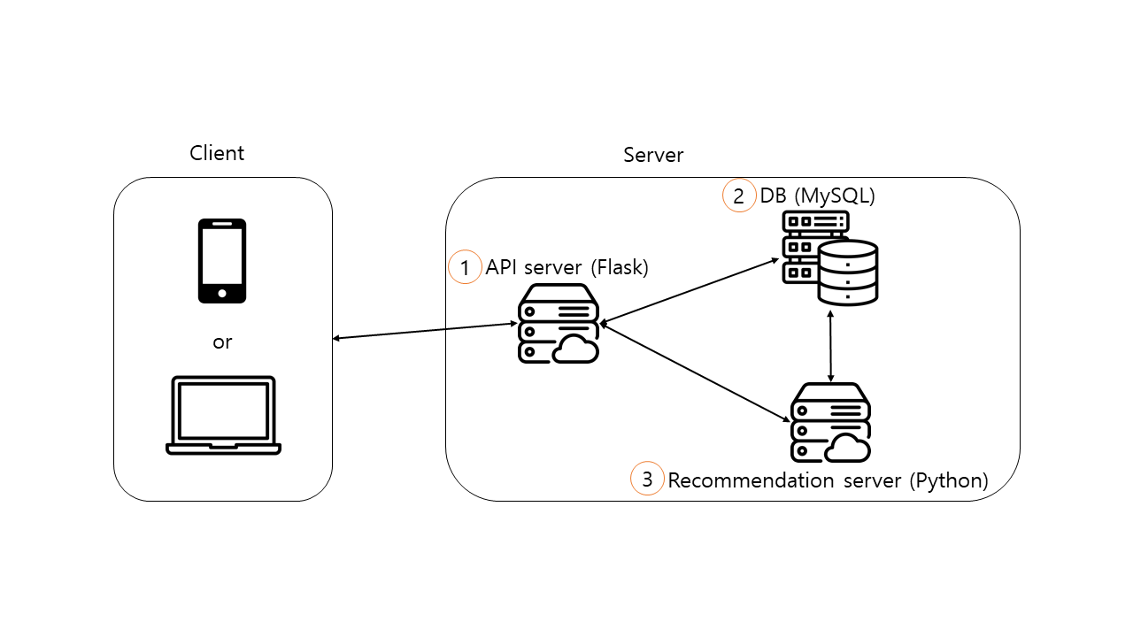

1. API server (Flask)
   1. Input
      1. API server (requests with REST API) -> Client (responds with JSON)
         1. POST login
         2. GET tododata
         3. PUT tododata
         4. GET recommendation
         5. POST logout
         6. DELETE account
   2. Output
      1. API server (requests with SQL query) -> DB (responds with data)
         1. SELECT/INSERT/UPDATE
      2. API server (requests with string through socket call) -> Recommendation server (responds with string data through socket)
         1. Get recommendation
2. DB (MySQL)
   1. Input
      1. API server (requests with MySQL query) -> DB (responds with data)
         1. SELECT/INSERT/UPDATE
      2. Recommendation system (requests with SQL query) -> DB (responds with data)
         1. SELECT
3. Recommendation System (Python)
   1. Input
      1. API server (requests with string through socket) -> Recommendation system (responds with string data through socket)
         1. Get recommendation
   2. Output
      1. Recommendation system (requests with SQL query) -> DB (procedure call: SQL query -> data)
         1. SELECT